# Introduction to the Labour Force Survey and Annual Population Survey Workshop

# **Navigating and using LFS documentation - ANSWERS**

## Questions from task: Part 1

Question 1: What is the name of the variable assigned to the question that asks about zero-hour contracts?

Answer: The variable **name is FLEX10**. The question is: *‘Some people have special working hours arrangements that vary daily or weekly. In your (main) job is your agreed working arrangement any of the following...’*

**Question 2:** What does the (1-3) in the name FLEX10(1-3) refer to?

Answer: The (1-3) relates to the note that **‘Respondents may give up to three responses’**. The first, second, and third responses are contained in different variables which have the suffixes 1, 2, or 3 added; for example, first responses are recorded in a variable called FLEX101. To find all the respondents who mention zero-hour contracts, you would need to sum responses across FLEX101, FLEX102 and FLEX103.

Question 3: What is the name of the derived variable that is labelled: Whether respondent works zero hours contract?

Answer: The variable **name is FLEXW7.**

**Question 4:** How does FLEXW7 vary from FLED10?

Answer: **FLEXW7** is derived from FLEX10(1-3), the variable only provides information about zero-hour contracts, it is a dichotomous variable (yes, no). It includes all mentions of whether a person has a zero-hour contract. **FLED10** is derived from FLEX10(1-3) responses, it has 10 categories of which zero-hour contracts is just one. FLED10, records the 'main' type of agreed work arrangement from the responses collected in FLEX10(1-3).

## Questions from task: Part 2

**Question 5.** What variables can you find to control for migrants in the analysis?

Answer: We can find the following, variables relating to migration:

CAMEYR – In which year did you first arrive in the UK?

CRY12 - In which country were you born?

CRYO7- Country of birth

CRYOX7 - CRYOX7- Country of birth (other)

If we check the data dictionary, we can find the EUL version contains grouped versions of CRYO7 and CRYOX7

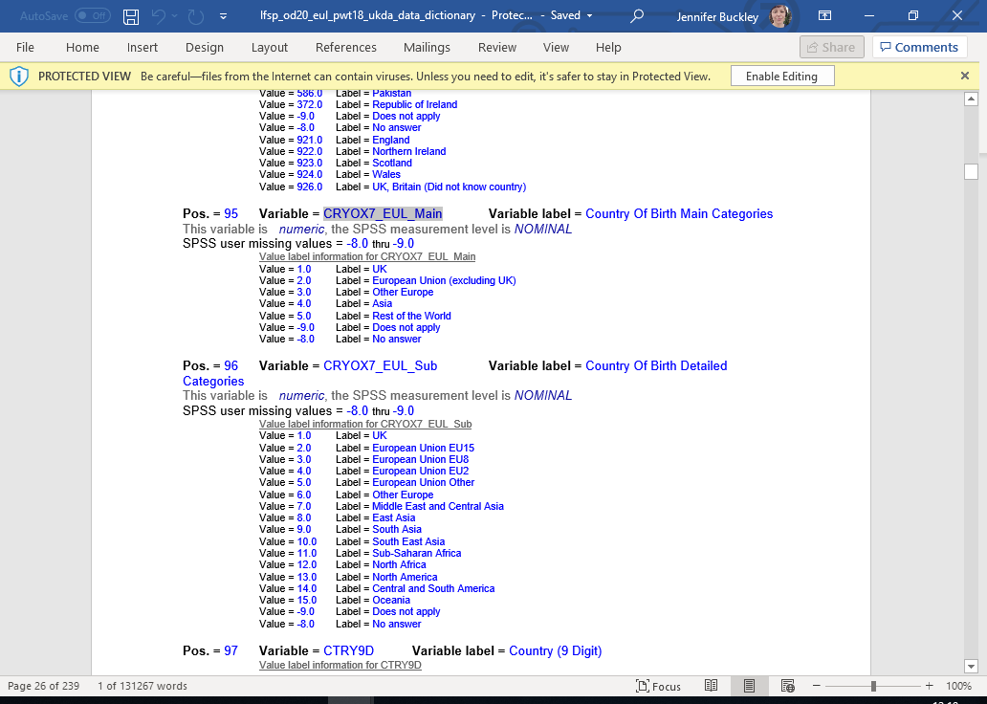

**Question 6.** What variables can you find to control for geography in the analysis?

Answer: Variables relating to geography:

GOR9D – Region

LAUA - Local authority district

NOTE: Vol. 3 more useful than Vol. 2 for identifying variables. The notes for LAUA indicate it is an APS variable. If you check the data dictionary for the EUL version, you can see it is not included. Volume 10 contains advice about which datasets support which forms of analysis.

**Question 7.** How would you carry out analysis to see if individuals move in and out of zero-hour contracts over time?

Volume 3 tells us that FLEXW7 is in Spring and Autumn quarters only. To look at movement in and out of zero-hours contracts, we would need to look across 5 quarters. If we looked at the data dictionary for [Labour Force Survey Five-Quarter Longitudinal Dataset, October 2019 - December 2020](https://beta.ukdataservice.ac.uk/datacatalogue/studies/study?id=8780#!/documentation), we would see that FLEXW7 is included.